The CAM-C90 WIFI CCTV IP 1080HD Wireless Camera with Motion detection and Recording ability remotely or Standalone with a Micro SD memory Slot ( Up to 128G)

The CAM-C90 is easy to install, and it can work either as a standalone CCTV camera or as a wireless IP CCTV camera with 1080 HD quality image quality. The camera’s design means it can be discreetly placed in a room and can connect directly or via the WIFI LAN and monitor access through the cloud application.

The CAM-C90 view can be adjusted using either the rotating bracket which will allow you to turn the camera targeting the viewing area required. or just simply stick it on a wall or using a magnetic sticker to put on a refrigerator or any metal surface.

The camera’s sleak design, with measurements of 10 cm diameter which allows the operator to place it where ever he wants in room without it being noticeable.

The CAM-C90 camera has a two way microphone which enables the user to remotely to speak to anyone in the room where the camera is situated, and also has a internal speaker so that the remote user can hear sound.

The camera is easy to install and will connect either to a smart phone or a computer via the cloud software . The remote user will be able to monitor the camera from anywhere in the world.

The camera’s activity can be saved via the cloud software on your notebook or if used as a standalone camera can be stored on a SD memory card.

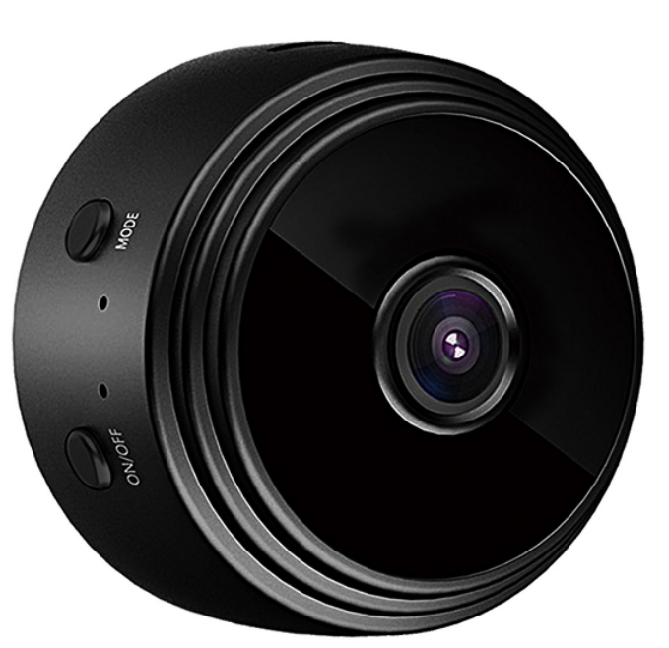

SPECIFICATIONS:
Resolution：4K/2K/1080P/720P
Number of frames：25
Video format：ASF
WIFI Compatibility: 11g/11n
Perspective：150 degrees
Motion Detection：6 meters straight
Minimum illumination：1LUX
Continuous recording：Over 1 hour
Compression format：H.264
Recording range：5m2
Power consumption：240MA/3.7V
stored temperature：-20-80 degrees Celsius
Operating temperature：-10-60 degrees Celsius
Operating humidity：15-85%RH
Memory card type：TF card (up to 128G)
Mobile operating system：Android/loS

Quick Guide for Watching
- Software installation & download and nstall APP for smart phones

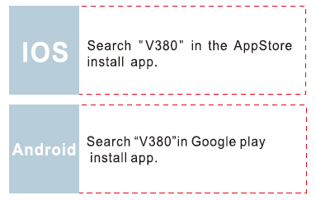



- How to use the AP hots pot connection device:
1. When hot build successful, open the mobile wireless Network Settings.
2. Find hot begin with MV, click on the links.
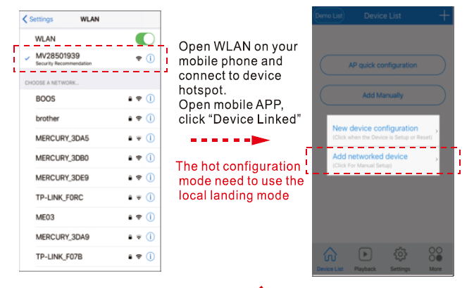
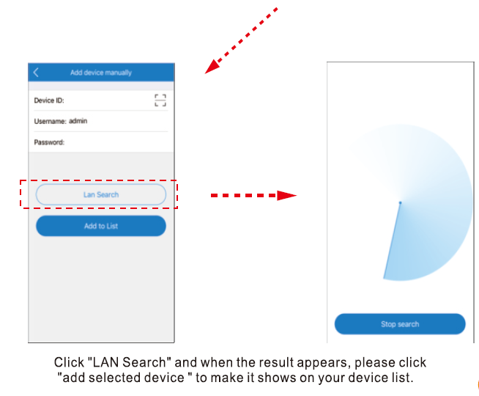
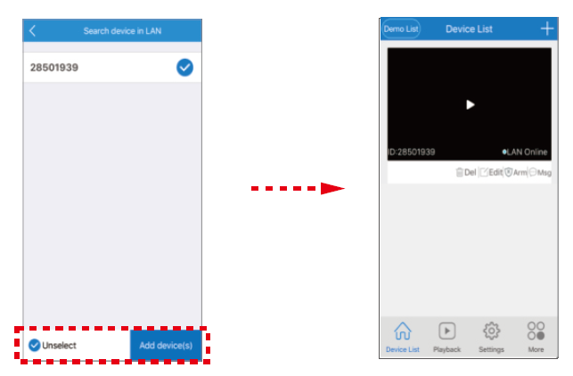

- Security and password
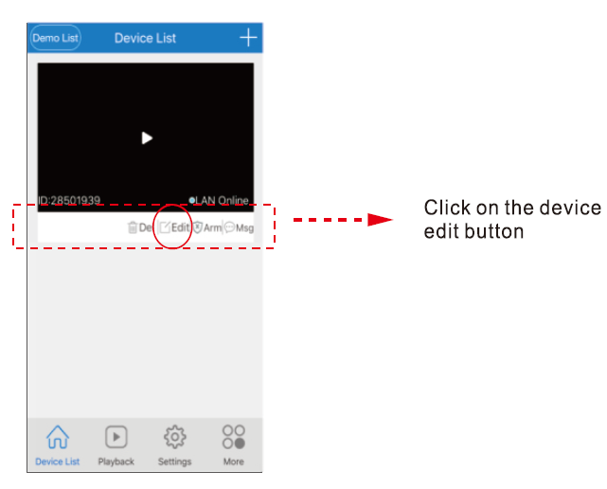
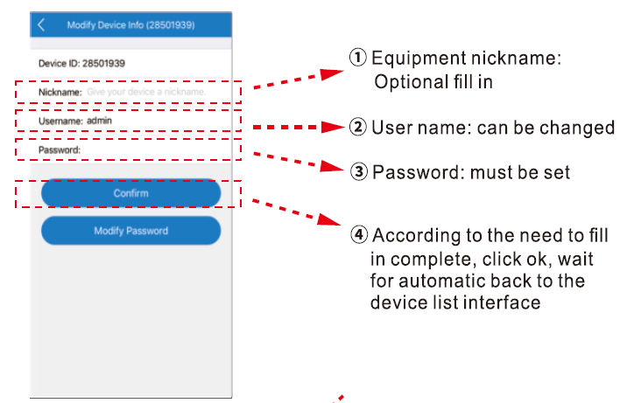
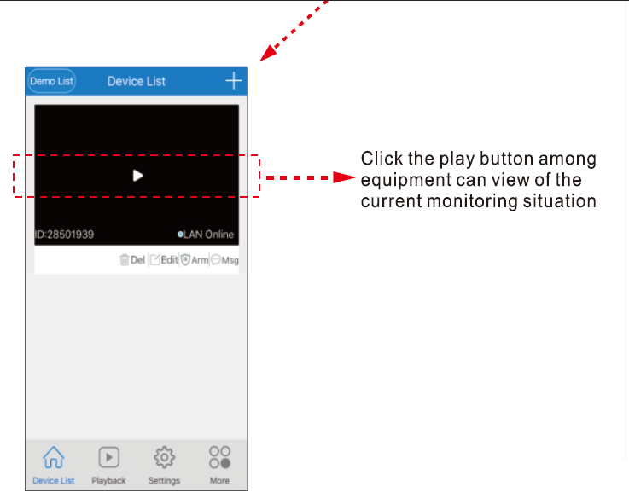

- Device settings
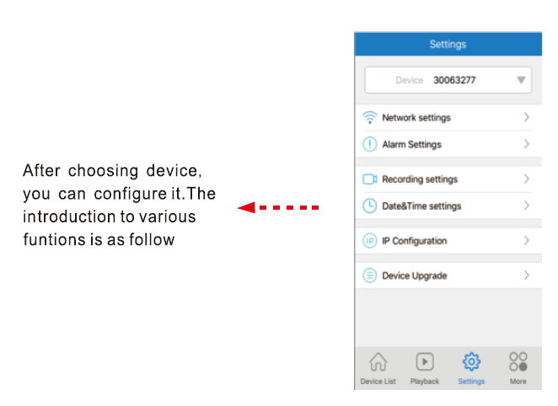
- Networksetting:
AP mode and station mode can be interchanged;
AP mode: Set the Camera work as a independed
Access Point(Hotpot),(The wi Camera work as a
WIFI Access Point,the pre xis' 'MV”,ex,"MV31000000")
Station mode: Set the Camera work as wi station,the
camera willconnect the Wi router you selected,and you
can access youcamera by inlernet

②Record Setting:
automatic record: continuous recording;
record-on-alarm: record with alarm event;
audio record: record the sound;
record resolution:
standard-de nition(VGA),
high-de nition(720P)(choose high-de nition record,with
big record les and short storagetime in memory card)

③Alarm & Prompt:
disarm switch: Close or Open the alarm;
voice master switch: master switch for all voice prompts;
alarm voice prompts: switch for movement alarm voice;
voice language: enable the voice prompts .

④Date & Time: able to adjust time of device;

⑤User Management: able to modify the username and
password of camera;

⑥Static IP configurantion: Equipment can be static
IP is set to manual configuration or automatic configuration;

⑦Version information: able to obtain information of
device system and hardware;

- Switch WIFI mode
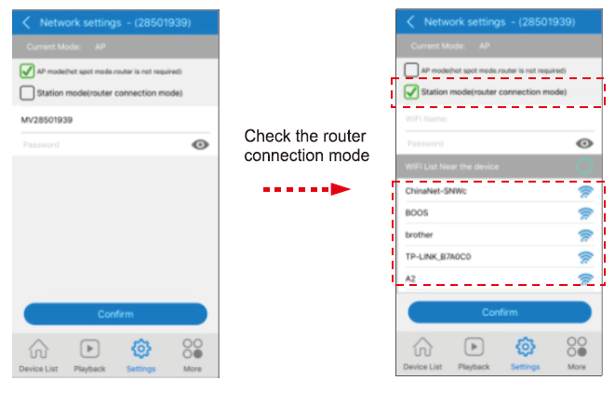
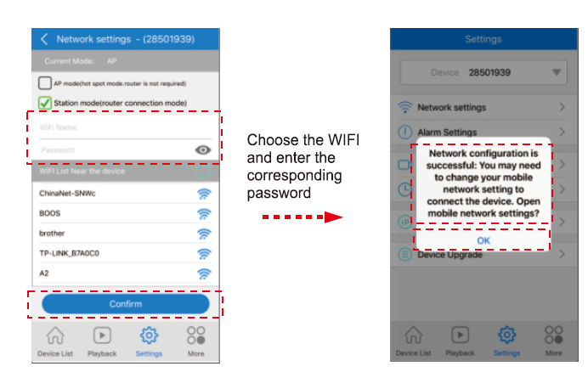
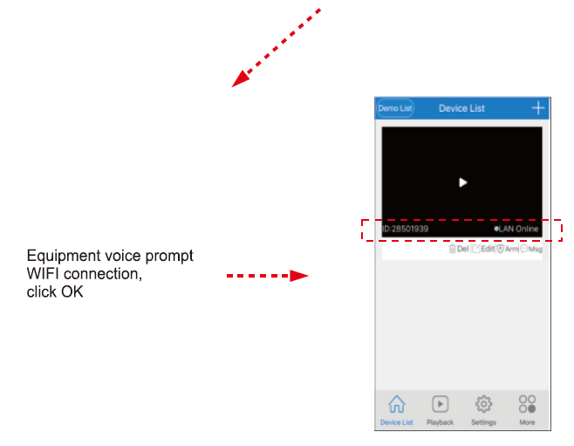
- Device control
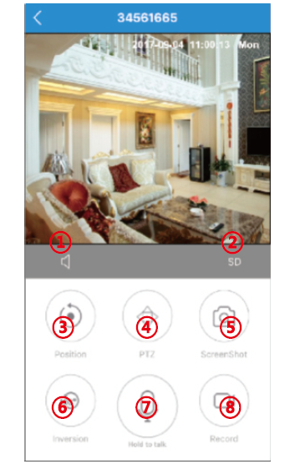
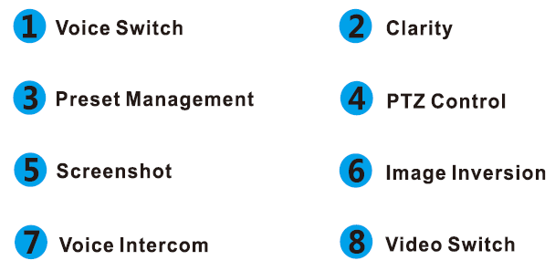

- Video playback
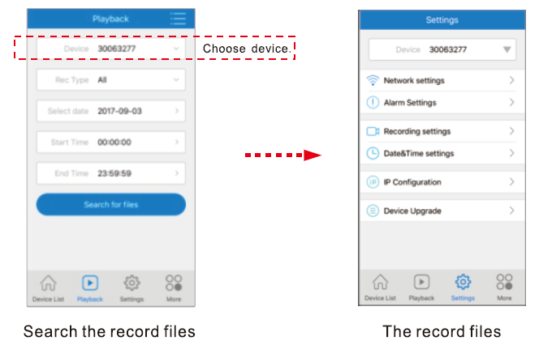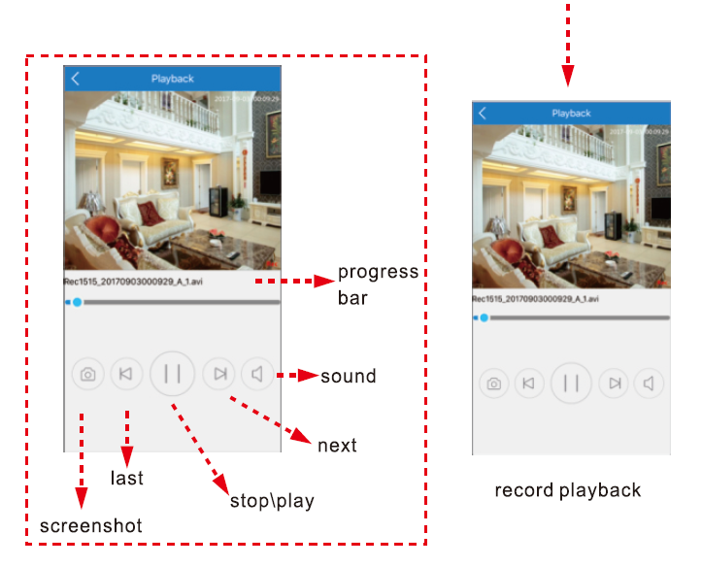

- More functions
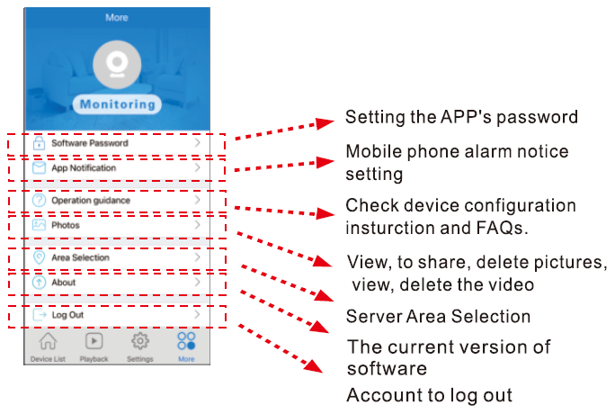

- Modify and delete
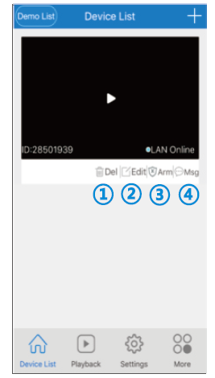
①Delete: able to delete one device entry individually
- Edit: able to modify ID number, username and password of the device (if you enter error username and password,you can modify it here directly, rather than adding another device entry)
- Arm:Protection, removal of equipment can be
- Megs: playback the snap picute
- Long press the device ID to proceed bulk deletions.(On the android mobile phones do not support this operation)

